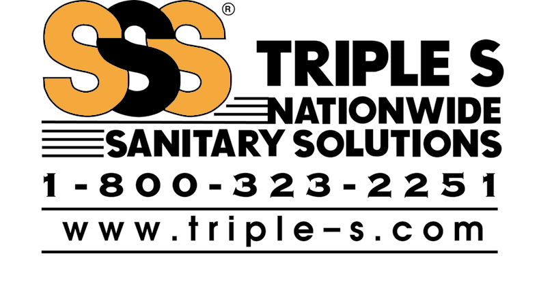

SSS OVEN & GRILL CLEANER

Features: • Institutional Strength
      - Caustic Formula
      - Spray On, Wipe Off
      - 360° Valve
      - Nonflammable

Descriptions: Formulated for hard-to-clean institutional ovens and cooking utensils. Works extremely well on outdoor barbecue grills, both gas and charcoal. Home ovens and pots and pans are cleaned easily, with far less effort than with conventional cleaners. Shines stainless steel to look like new. Do not allow cleaner to remain on asphalt tile. DO NOT USE ON ALUMINUM.

Markets: Restaurant & fast food establishments, hospitals, nursing homes, apartment complexes, schools, colleges, supermarkets & supermarket deli areas, caterers, housing authorities, country clubs, churches, day care facilities, bakers, bowling alleys, fraternal organizations.

Demonstrations: Obtain three inexpensive drip pans from market.

- Cook, burn food, and generally trash pans for one week. Leave one soiled, clean one totally, and clean half of the third, marking off the other half w/ plastic and tape so as to have 1/2 clean - 1/2 soiled pan. The purpose of the above is that the product needs a 10 - 20 minute dwell time to be effective - longer than desired for demos.
- To show strength of caustics, use its effect on aluminum foil. Spray sheet of foil, and immediately ball up the foil. The foil will immediately begin to give off visible fumes and get very hot, showing strong corrosive reaction from strong caustics.
- If on site, you can demo on any available surface per label copy instructions for use. Always be cautious and follow directions due to the high caustic level of this product.

